To: Editor in Chief
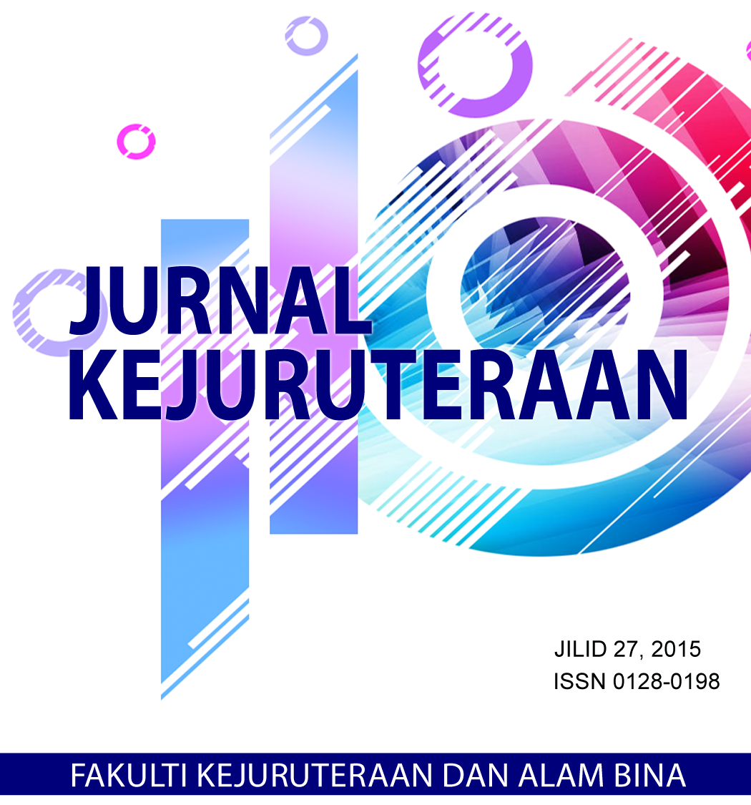

Jurnal Kejuruteraan (Journal of Engineering)
Penerbit UKM Press
Universiti Kebangsaan Malaysia
43600 UKM Bangi
Selangor, Malaysia

Dear Sir / Madam,

SUBMISSION OF A MANUSCRIPT FOR JURNAL KEJURUTERAAN

The above matter is referred.

- I am sending a copy of a manuscript, which I would like to submit to Jurnal Kejuruteraan

*Title :
*Corresponding Author :
*Name :
*Address :
*E-mail :

- I hereby certify that:

- The manuscript represents original work, that has not been published or under consideration for publication elsewhere.
- In the event that Penerbit UKM Press publishes my work, I hereby transfer, assign, or otherwise convey all copyright ownership to Penerbit UKM Press.
- All authors name that I have listed in this article have agreed and acknowledged my intention for publication in Jurnal Kejuruteraan.

- Potential reviewers are as the following:

- You must give the names, organisations and organisation email addresses of four (4) independent referees.
- Two (2) referees can be nominated within your country and another two (2) should come from abroad.
- The referees must be independent and not from your own organisation.
- Use the fields below to give us contact information for each suggested reviewer, and please provide specific reasons for your suggestion in the comments box for each person.

*Name :
Designation :
Affiliation :
*Email :
*Specialisation :

*Name :
Designation :
Affiliation :
*Email :
*Specialisation :

*Name :
Designation :
Affiliation :
*Email :
*Specialisation :

*Name :
Designation :
Affiliation :
*Email :
*Specialisation :

I hope your favorable consideration and look forward for publication in Jurnal Kejuruteraan

Thank you very much.

*Signature :
*Name :
*Address :
*Tel. No. :
Fax. No :
*Date :

